3D Game Basic – Final Term

Group 9 – Turn Around

Frédéric Ye - 7001916

Responsible of the Robot AI

Sommaire

Task 1: Creation of the NavMeshAgent 2

Task2 : RayCast to order the robot 3

Task 3: Robot Canvas 4

Task 4: Make the robot fall 5

Task 5: Respawn robot 6

Task 6: Platform Activation with Particle system 7

Task 7: Where can we find the robot ? 8

Conclusion 9

# Task 1: Creation of the NavMeshAgent

Pretty easy, after that I needed to make him move toward the player.

Same no real difficulty.

# Task2 : RayCast to order the robot

A bit difficult first to understand how raycast works but it was finie.

But Raycast doesn’t work on NavMeshAgent so I needed to add a Sphere Collider on Robot.

# Task 3: Robot Canvas

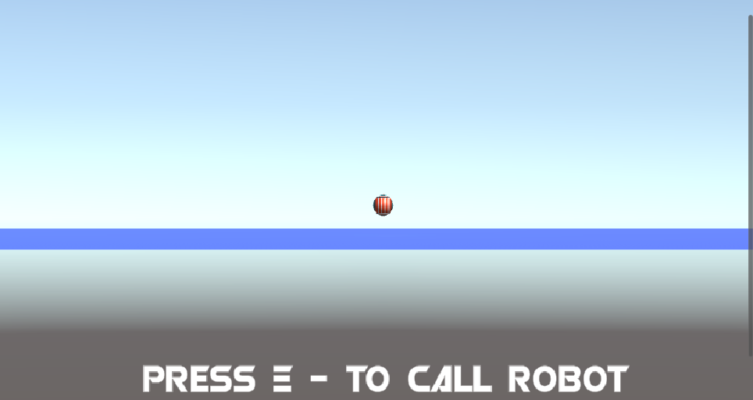

The only tricky part was to activate it when the raycast touch the robot.

# Task 4: Make the robot fall

The trickiest part of my assignation. NavMeshAgent aren’t affected by gravity, so I needed to add a rigidbody. Rigidbody and NavMeshAgent doesn’t work well together. So, to make him fall, I needed to disable the NavMeshAgent and reactivated the rigidbody.

# Task 5: Respawn robot

Dismantle and reassemble the robot.

Just a spawner.

# Task 6: Platform Activation with Particle system

It will make the platform change color when the robot walk on it.

# Task 7: Where can we find the robot ?

I forgot where I download it so I will just put the inside of the license file.

3ds max 2016 - 2017 - 2018 - 2019

fbx - 3ds - obj export

5 piece 1920x1080 render

1 piece wireframe render

vray next

15168 poly

15454 verts

# Task8: Robot Sound

There’s sound on the robot for the different action: Spawning, Falling, Explosion and Clear the level.

# Conclusion

Overall, it’s my first time I made the IA of a project, it was a bit hard at the start to understand how NavMesh really works and how it is when used with rigidbody. Particle is always fun to use and play around. I’m happy of the works done on my little robot.  
I have no regret of what was done.

Frédéric Ye - 7001916